1.Write a python program to test a given number is prime or not.

num = int(input("enter the number : "))

if num > 1:

for i in range(2, int(num/2)+1):

if (num % i) == 0:

print(num, "is not a prime number")

break

else:

print(num, "is a prime number")

else:

print(num, "is not a prime number")

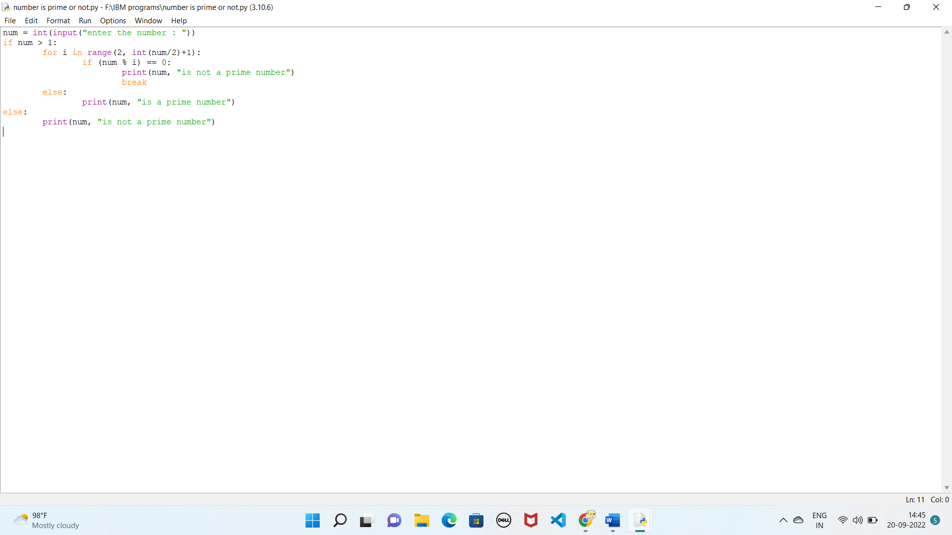

Output: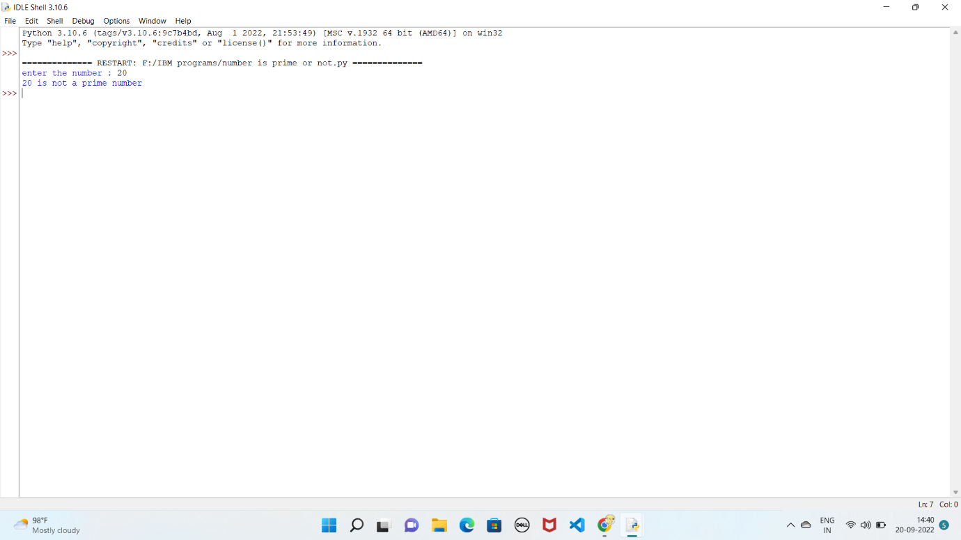

2.write a program to generate odd numbers from m to n using while loop.

minimum = int(input(" please Enter any minimum value:"))

maximum = int(input(" Please Enter any Maximum Value : "))

X=1;

if (minimum < maximum):

while X in range(minimum,maximum + 1):

if( X % 2 != 0):

print("{0}".format(X))

X=X+1;

else:

print("Minimum value you've entered is greater than maximum value")

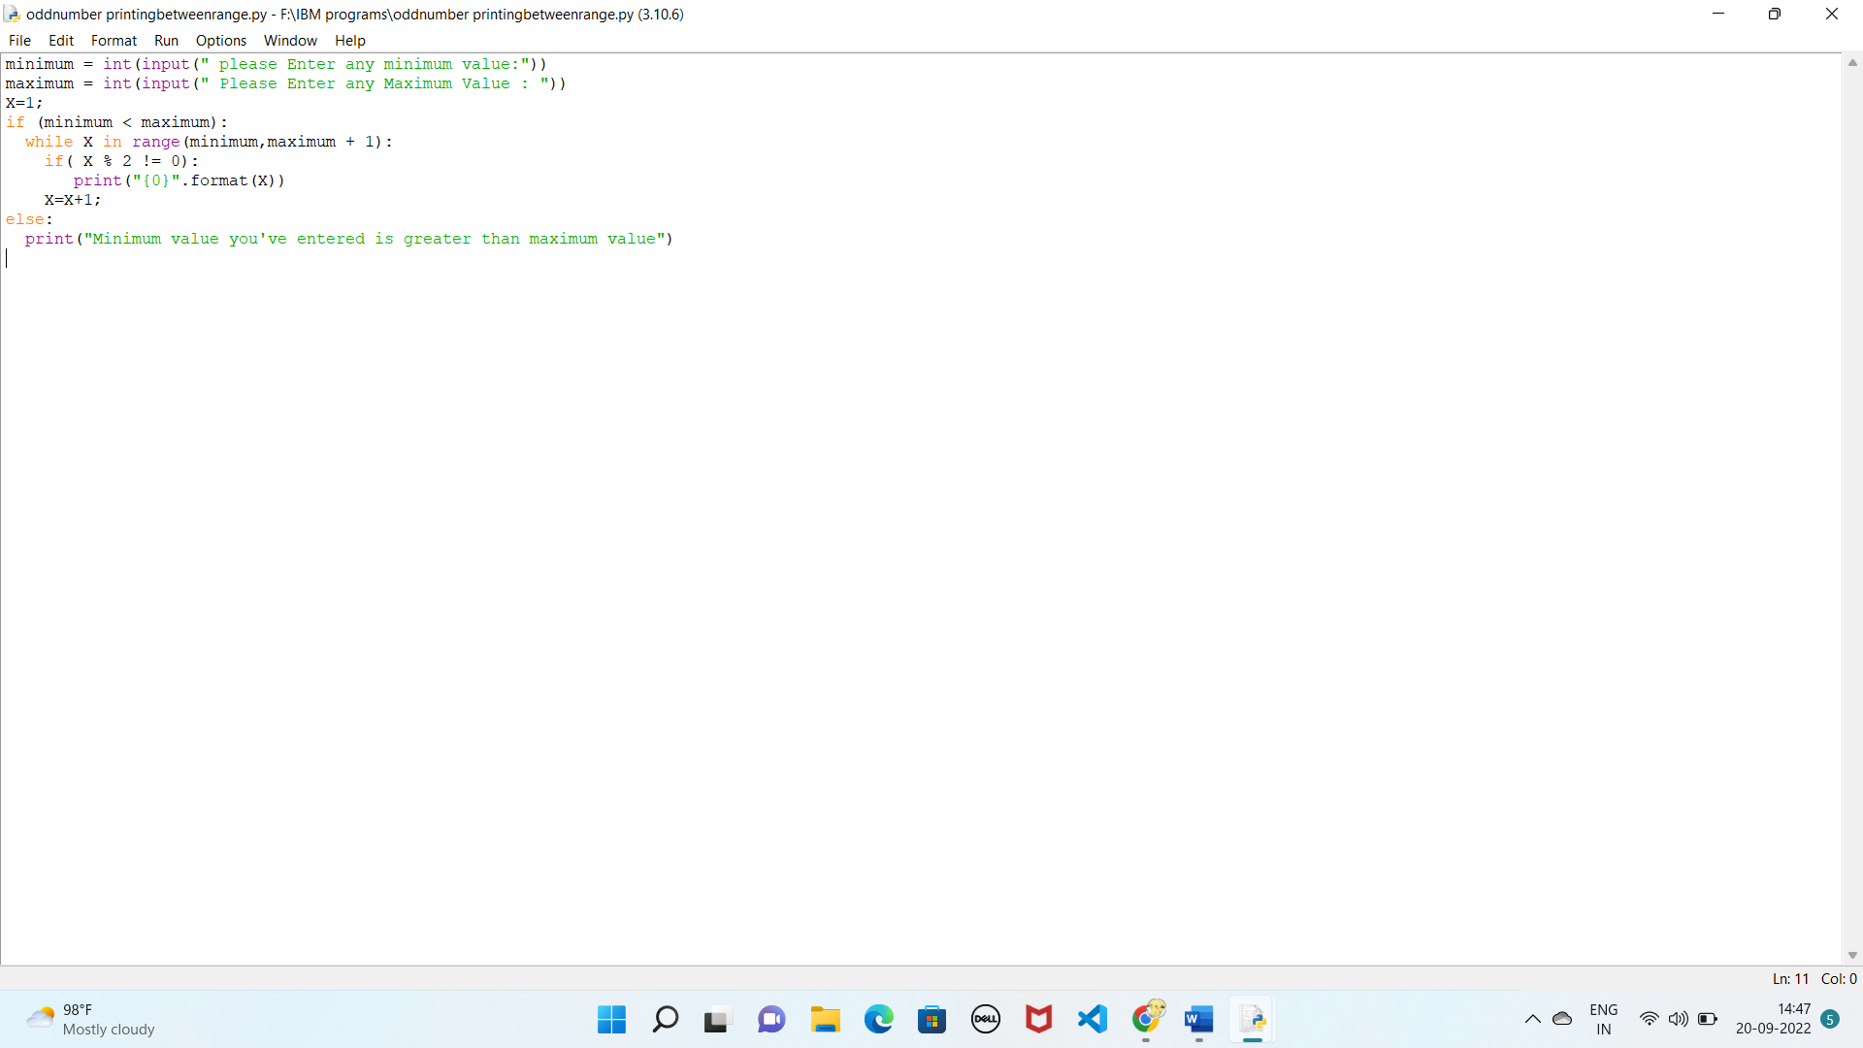

Output:

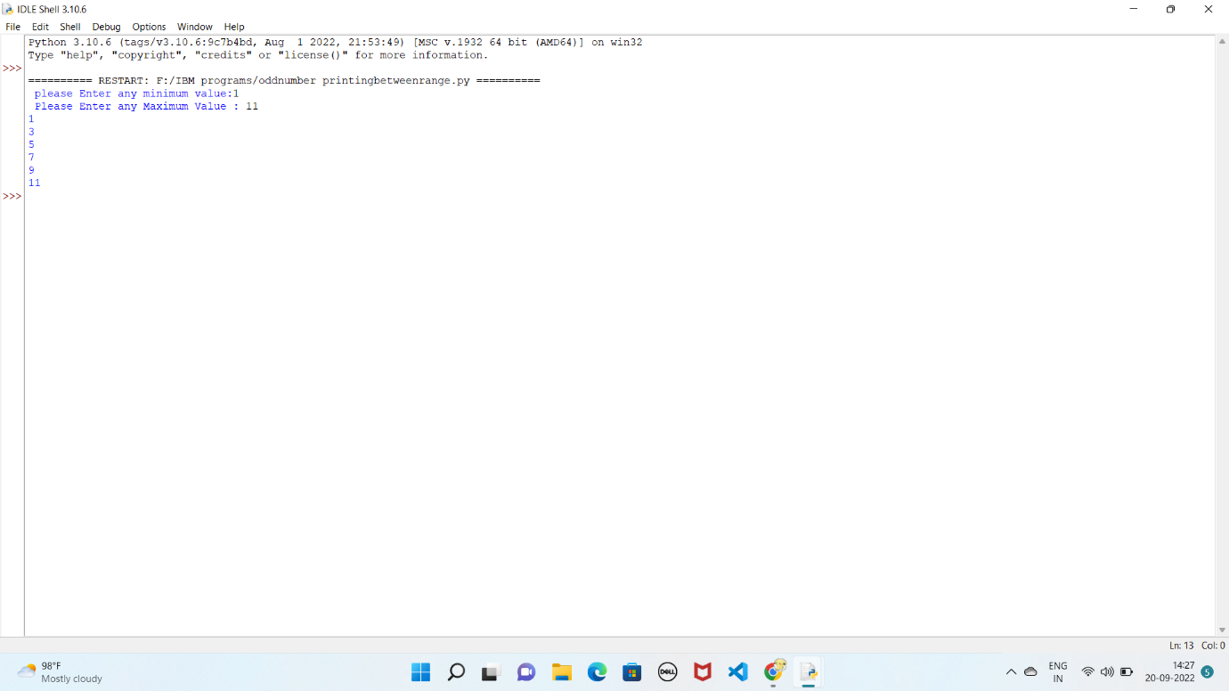

3.Write a python program to display prime number series up to given number.

lower = 1

upper = int(input("Enter the number upto which prime numbers are found : "))

print("Prime numbers between", 1 , "and", upper, "are:")

for num in range(lower, upper + 1):

if num > 1:

for i in range(2, num):

if (num % i) == 0:

break

else:

print(num)

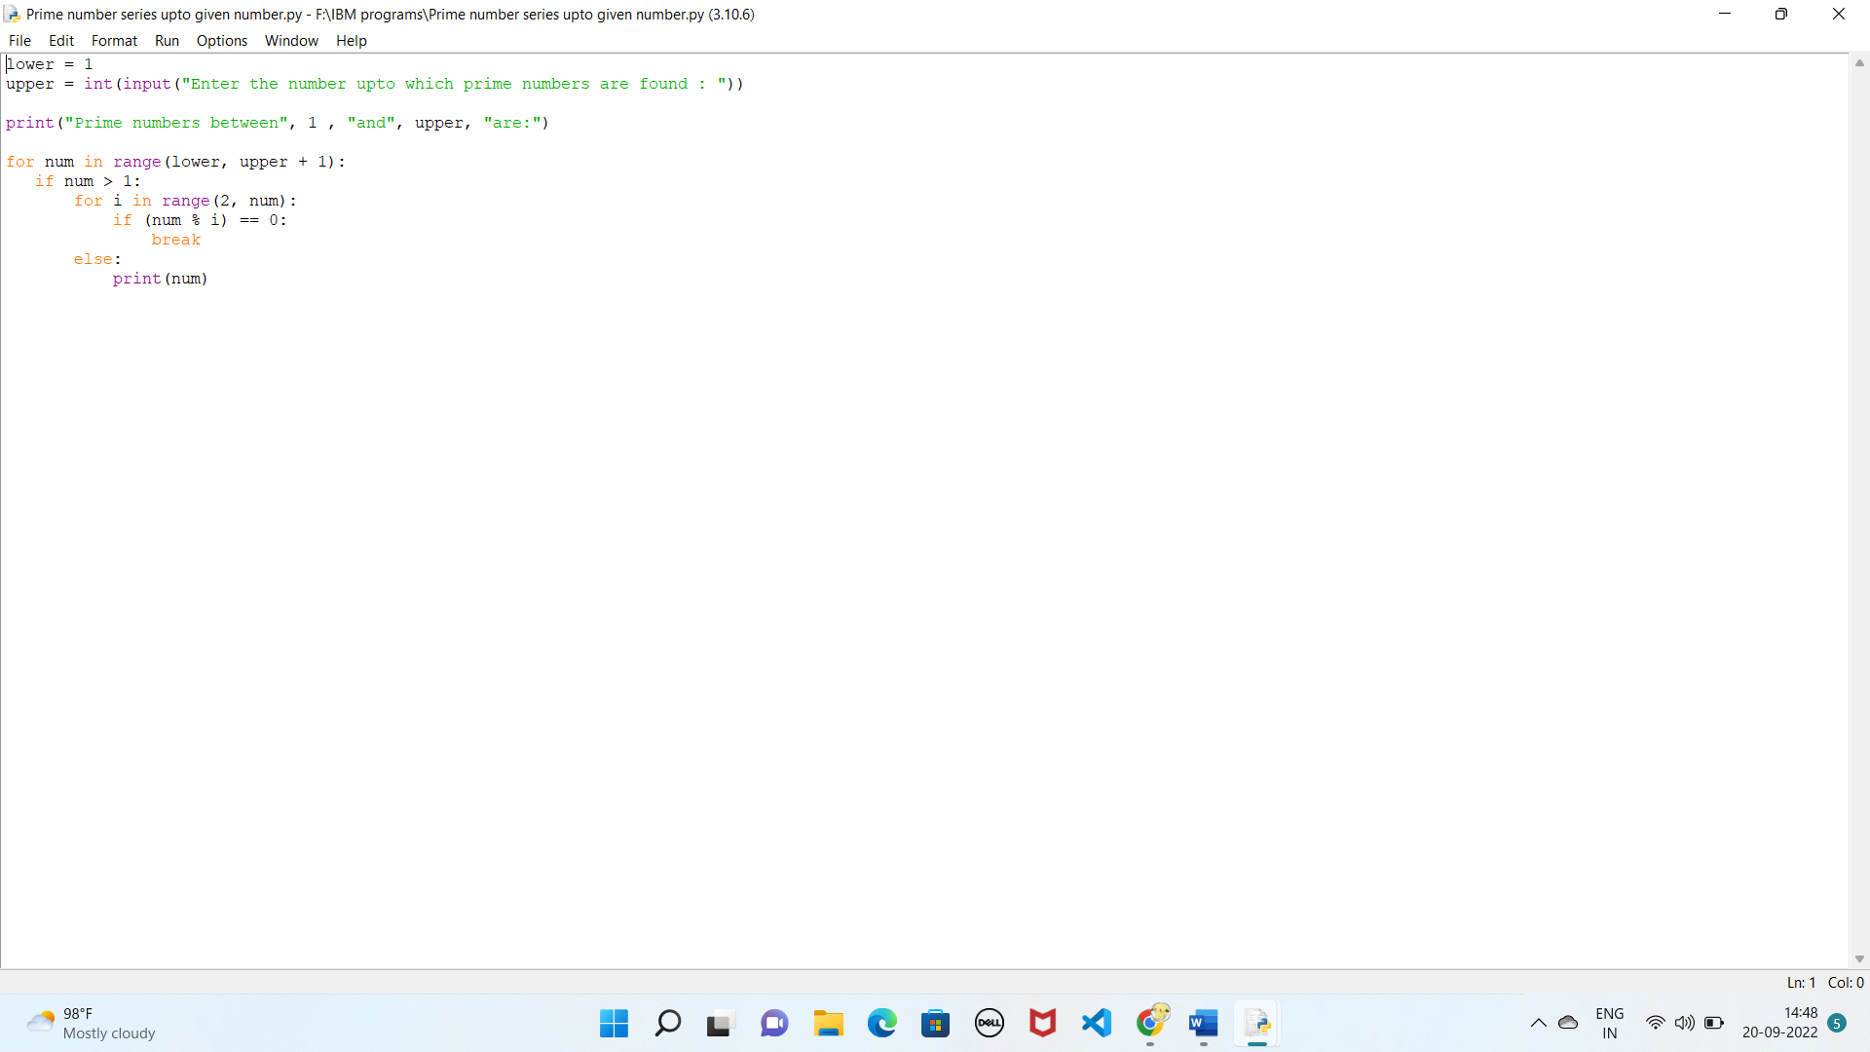

Output: 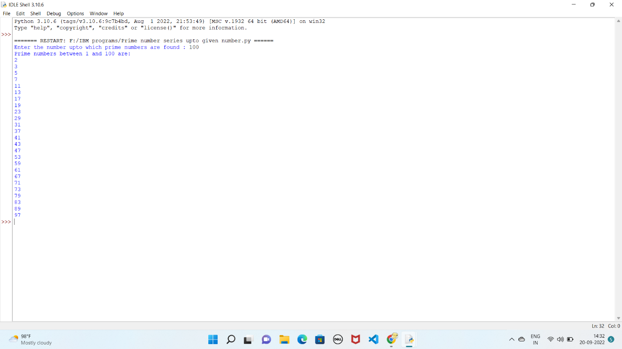

4.write a python program to generate Fibonacci Series.

number = int(input("enter the number :"))

def Fibonacci(n):

if n < 0:

print("Incorrect input")

# Check if n is 0

# then it will return 0

elif n == 0:

return 0

# Check if n is 1,2

# it will return 1

elif n == 1 or n == 2:

return 1

else:

return Fibonacci(n-1) + Fibonacci(n-2)

print(Fibonacci(number))

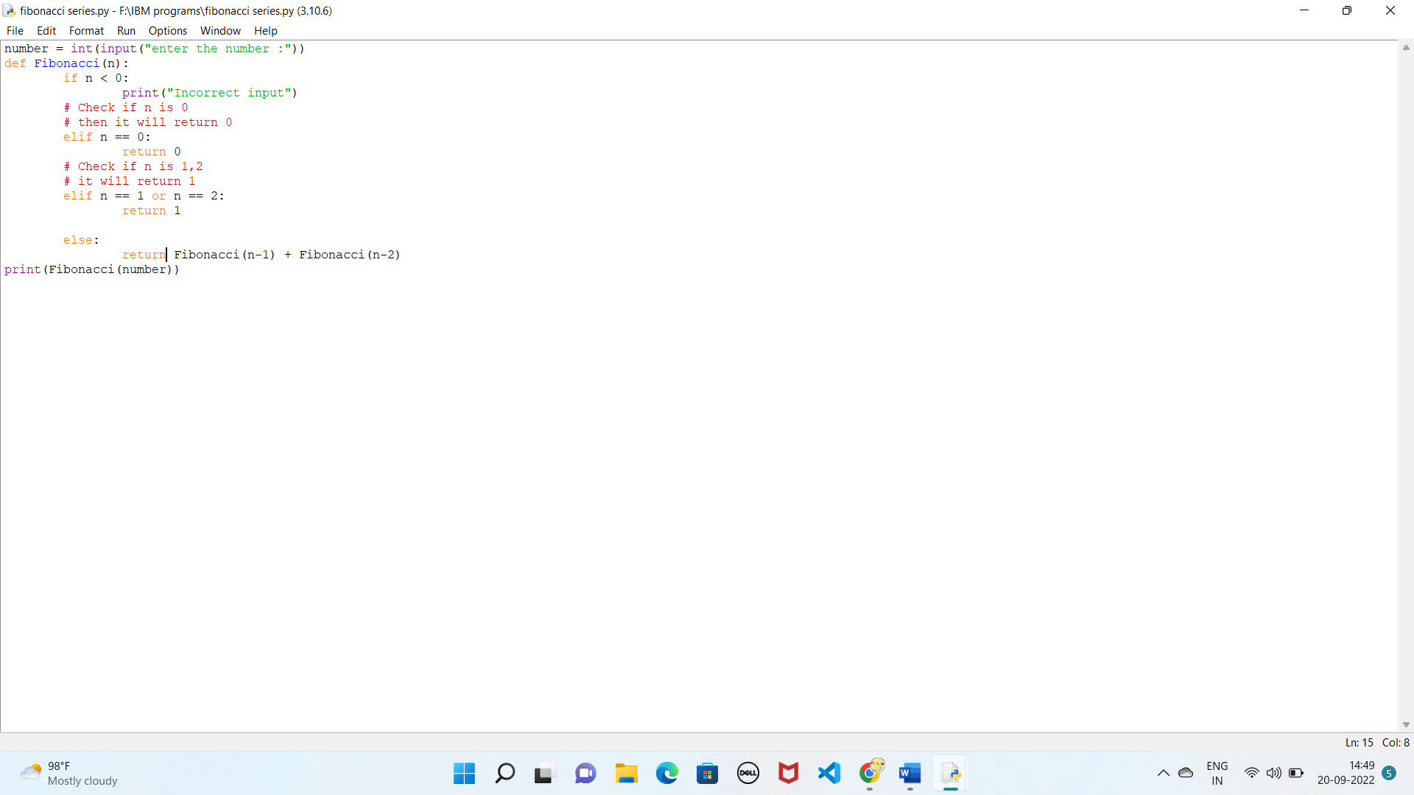

Output: 